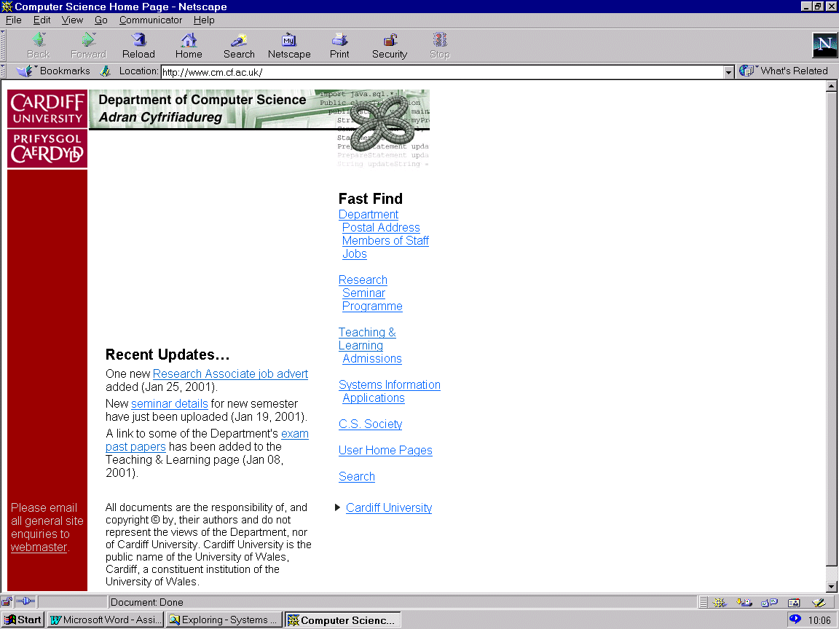CM1202: Developing Quality Software

Module Leader: Helen Phillips

Other module Lecturers: Alia Abdelmoty

Assignment – Design a Personal Tutor Management system for COMSC

Hand out date: Tuesday 24th January 2017

There are various hand in dates for the different sections. You will have been informed of these dates in the first lecture and can find the dates on the Module schedule on learning central. You will be provided with detailed information about the tasks and assessment criteria for each specific piece of work at appropriate points during the module.

Scenario

Background to the problem
At the start of the university’s academic year, senior personal and academic tutors throughout Cardiff University spend considerable time assigning new students, undergraduate and postgraduate, personal tutors. Although the assignment might seem random, students are assignment to appropriate staff where possible. For example within Computer Science and Informatics (COMSC), students on the specialist degree are assigned to staff within those research groups; also where possible students are placed in personal tutor groups that consist of students on one particular degree programme.

The current COMSC process - before students can be assigned personal tutors, at the start of the year, the senior personal tutor needs to obtain a list of staff who will be undertake personal tutor duties, this list is provides by the head of school. The list changes year to year, as new lecturers are employer, leave or go on a period of research leave. We then decide which staff members will have undergraduate (UG) tutees and which postgraduate (PG) tutees and how many tutees each staff member will be assigned. PG tutees are assigned following enrolment, however UG tutees are assigned at the start of September once UCAS and clearing has finished when the UG Senior personal tutor is provided with a spreadsheet, CSV file listing all the new UG students from the admissions tutor. In addition to assigning new students tutees, personal tutors will have to be reassigned for other current student, if academic staff have left or are on research leave for that year.

During the academic year, senior personal tutors will need to search for the personal tutor for a particular student, provide staff with an up-to-date list of their tutees, and provide management with the number of tutees each staff member has been assigned per year or degree group. The tutor list also needs updating when students withdraw. Occasionally students are individually reassigned tutors on request, this is usually if they transfer degree programmes.

At the end of the academic year following the examination boards, the Senior Personal Tutor will update the CSV files ready for the next academic year.

Task: Your team has been asked by COMSC to develop a prototype personal and academic tutor system. A stand-alone application to be used by the schools senior personal and academic tutor.

COMSC’s aim is to reduce the Senior Personal Tutors workload at a very busy time of year, allowing then more time to co-ordinate the other enrolment activities. For the PG Senior personal tutor this is even more important given that currently they have an even quicker turn around time. Additional potential benefits that COMSC hopes to achieve are a more reliable up to date list and the opportunity for more advanced assignment algorithms.

The prototype must assist the senior personal and academic tutor to undertaking the tasks mentioned above in ‘Background to the problem’ these include but are not restricted to:
- assigning new students to tutors,
- searching the personal tutor list for individual students,
- displaying lists of tutees for a particular personal tutor
- provide information on the quota of tutees each staff member has been assigned per year or degree group

The scenario above provides you with the basic requirements however you may wish to extend your software package. Some possible examples are:
- Re-assigning students to tutors,
- Senior personal tutor can assign different numbers of tutees to full / part time staff
- More advanced listings
- A slightly more advanced assignment algorithm
- You may add any other features that appeal to you, if you so desire!

